**FLOWCHART TO CALCULATE SIMPLE INTEREST, 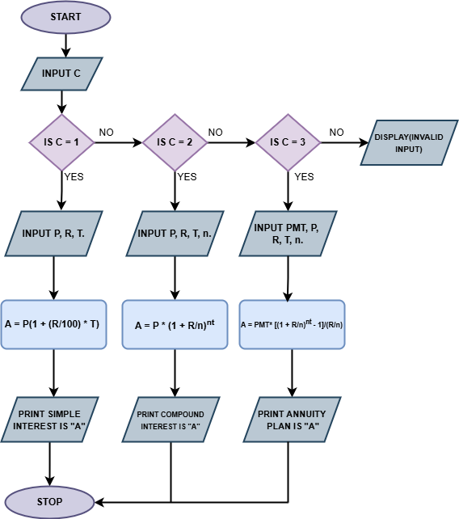COMPOUND INTEREST AND ANNUITY PLAN**